[Skip to main content](https://lms.alnafi.com/xblock/block-v1:alnafi+DCCS102+2025_DCCS+type@vertical+block@bfc73db8fd924fc280eeba442f4f158f?exam_access=&recheck_access=1&show_bookmark=0&show_title=0&view=student_view" \l "main)

**Summary**

The provisioning of accounts presents an opportunity for an attacker to create a valid account without the application of the proper identification and authorization process.

**Test Objectives**

* Verify which accounts may provision other accounts and of what type.

**How to Test**

Determine which roles are able to provision users and what sort of accounts they can provision.

* Is there any verification, vetting and authorization of provisioning requests?
* Is there any verification, vetting and authorization of de-provisioning requests?
* Can an administrator provision other administrators or just users?
* Can an administrator or other user provision accounts with privileges greater than their own?
* Can an administrator or user de-provision themselves?
* How are the files or resources owned by the de-provisioned user managed? Are they deleted? Is access transferred?

**Example**

In WordPress, only a user's name and email address are required to provision the user, as shown below:

[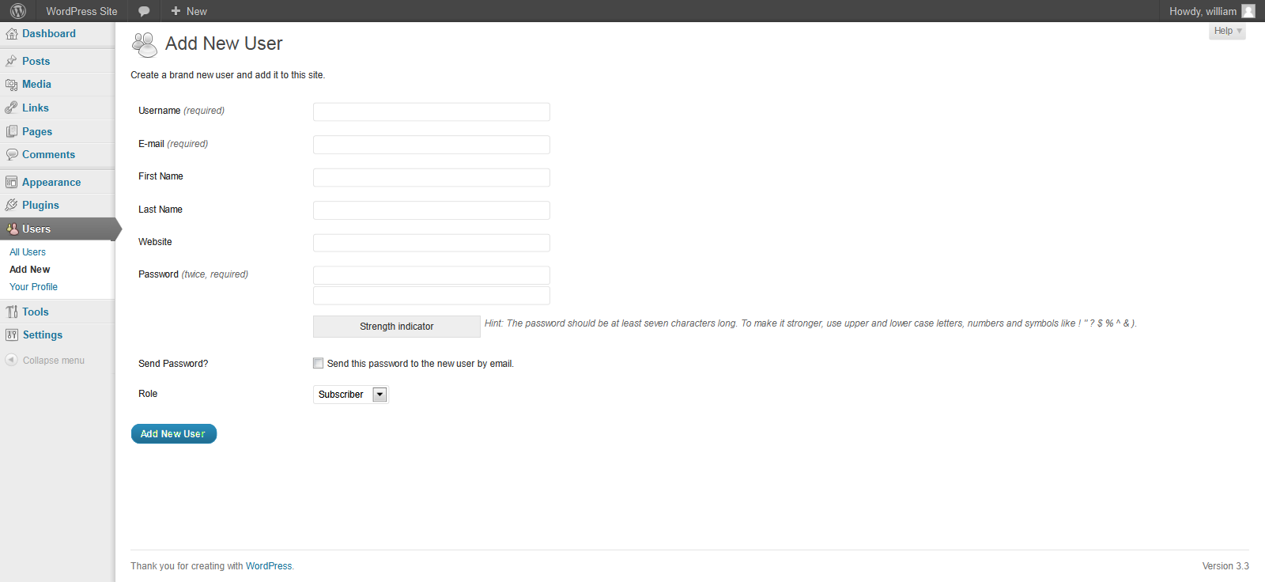](https://github.com/OWASP/wstg/blob/master/document/4-Web_Application_Security_Testing/03-Identity_Management_Testing/images/Wordpress_useradd.png)  
*Figure 4.3.3-1: WordPress User Add*

De-provisioning of users requires the administrator to select the users to be de-provisioned, select Delete from the dropdown menu (circled) and then applying this action. The administrator is then presented with a dialog box asking what to do with the user's posts (delete or transfer them).

**[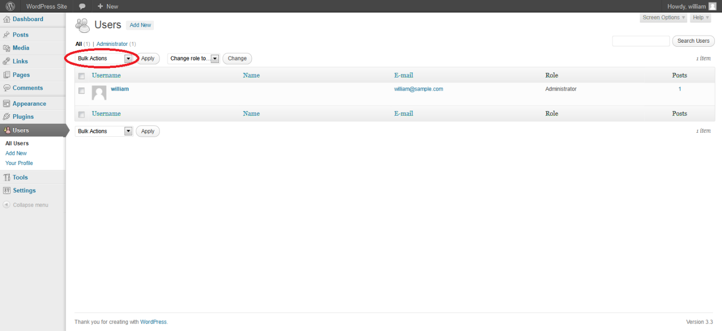](https://github.com/OWASP/wstg/blob/master/document/4-Web_Application_Security_Testing/03-Identity_Management_Testing/images/Wordpress_authandusers.png)**

**Tools**

While the most thorough and accurate approach to completing this test is to conduct it manually, HTTP proxy tools could be also useful.